**[Postman] Trello API – tips**

Before you send requests you need to get your own key and token for your Trello Account:

1. Create account on Trello ([www.trello.com](http://www.trello.com)).
2. Create account on Trello Developers (<https://developer.atlassian.com/cloud/trello/>).
3. Go to <https://developer.atlassian.com/cloud/trello/guides/rest-api/api-introduction/> and read base informations.
4. Next go to <https://trello.com/app-key> and get your API key.
5. On that same site click „Token” word and go with their instructions to get your own token.

Now you can add your key and token to variables. Also you should create second normal Trello Account on your second e-mail and add this e-mail too:  
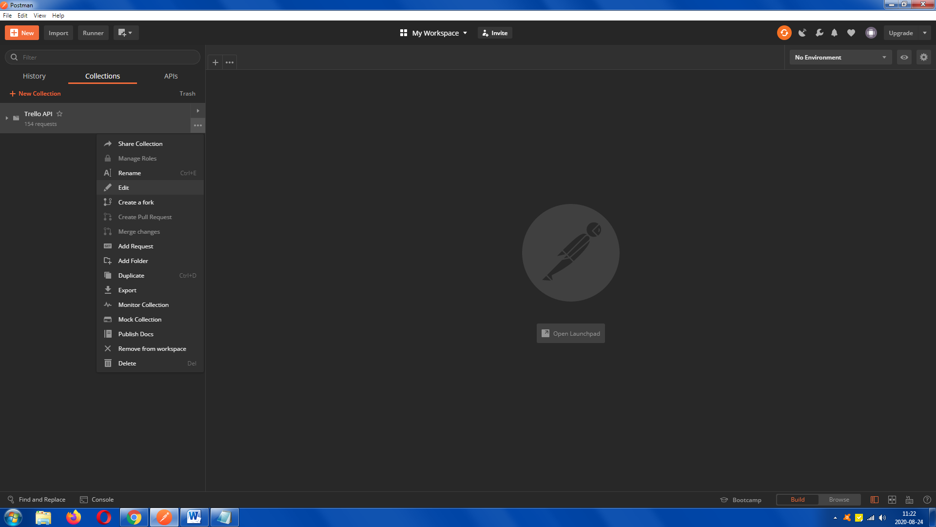

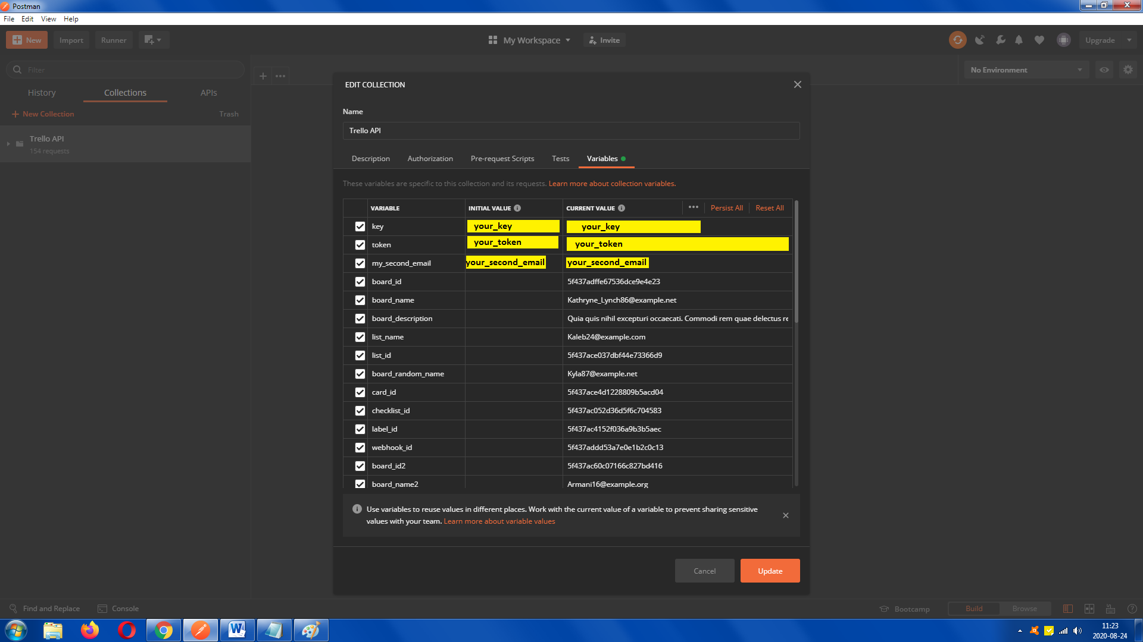

In „Organizations tests” one request need upload a file as logo. This file is also in repository. To make sure it works for yours Postman you need to set in settings path or (even better) „Allow reading files outside working directory” on ON.

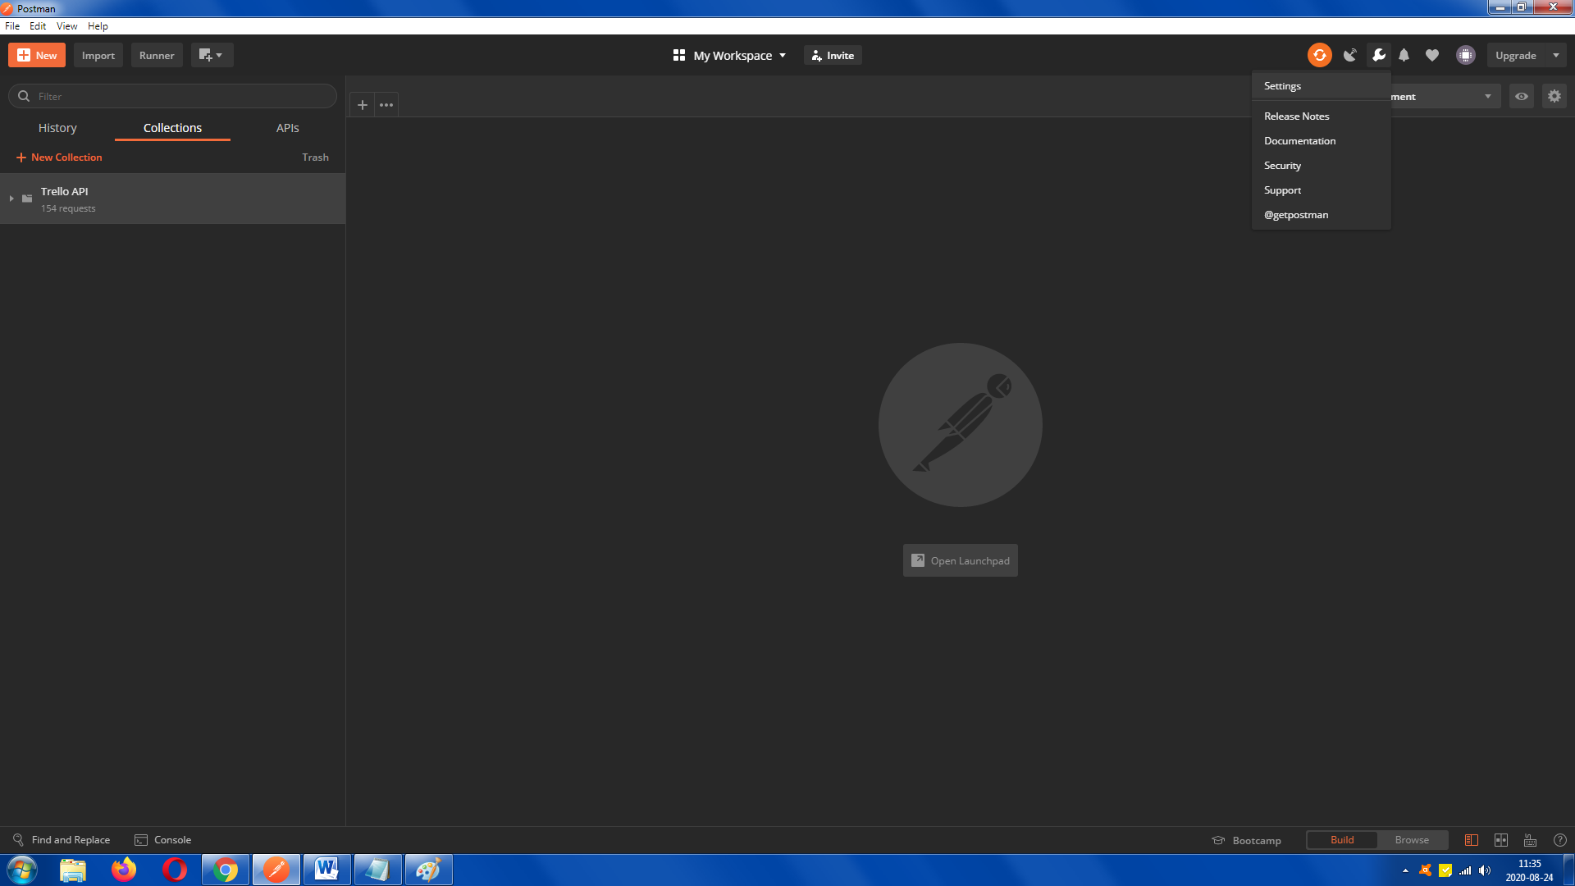

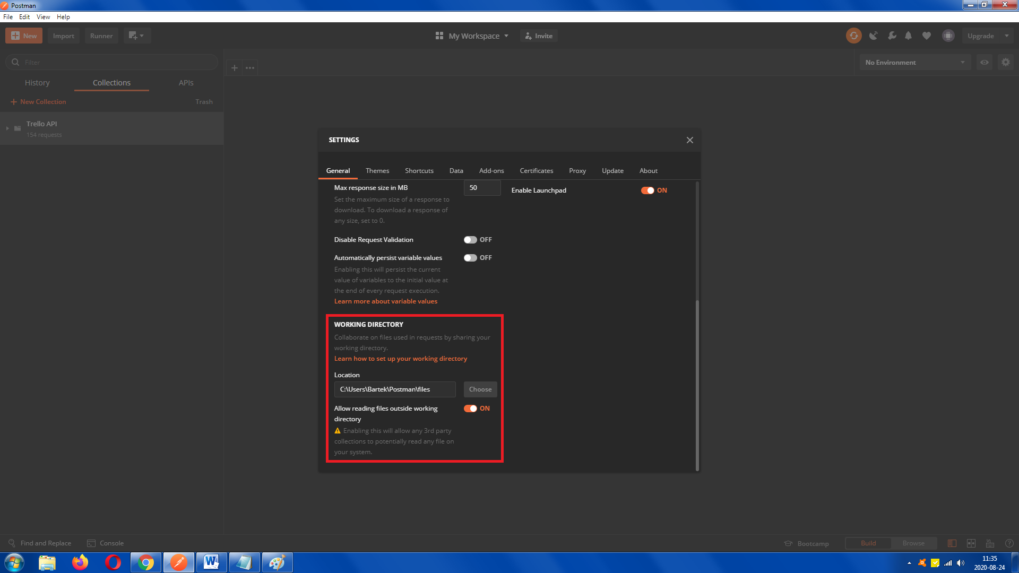

To run my requests on your Postman you should download repository and in Postman’s settings import this file:

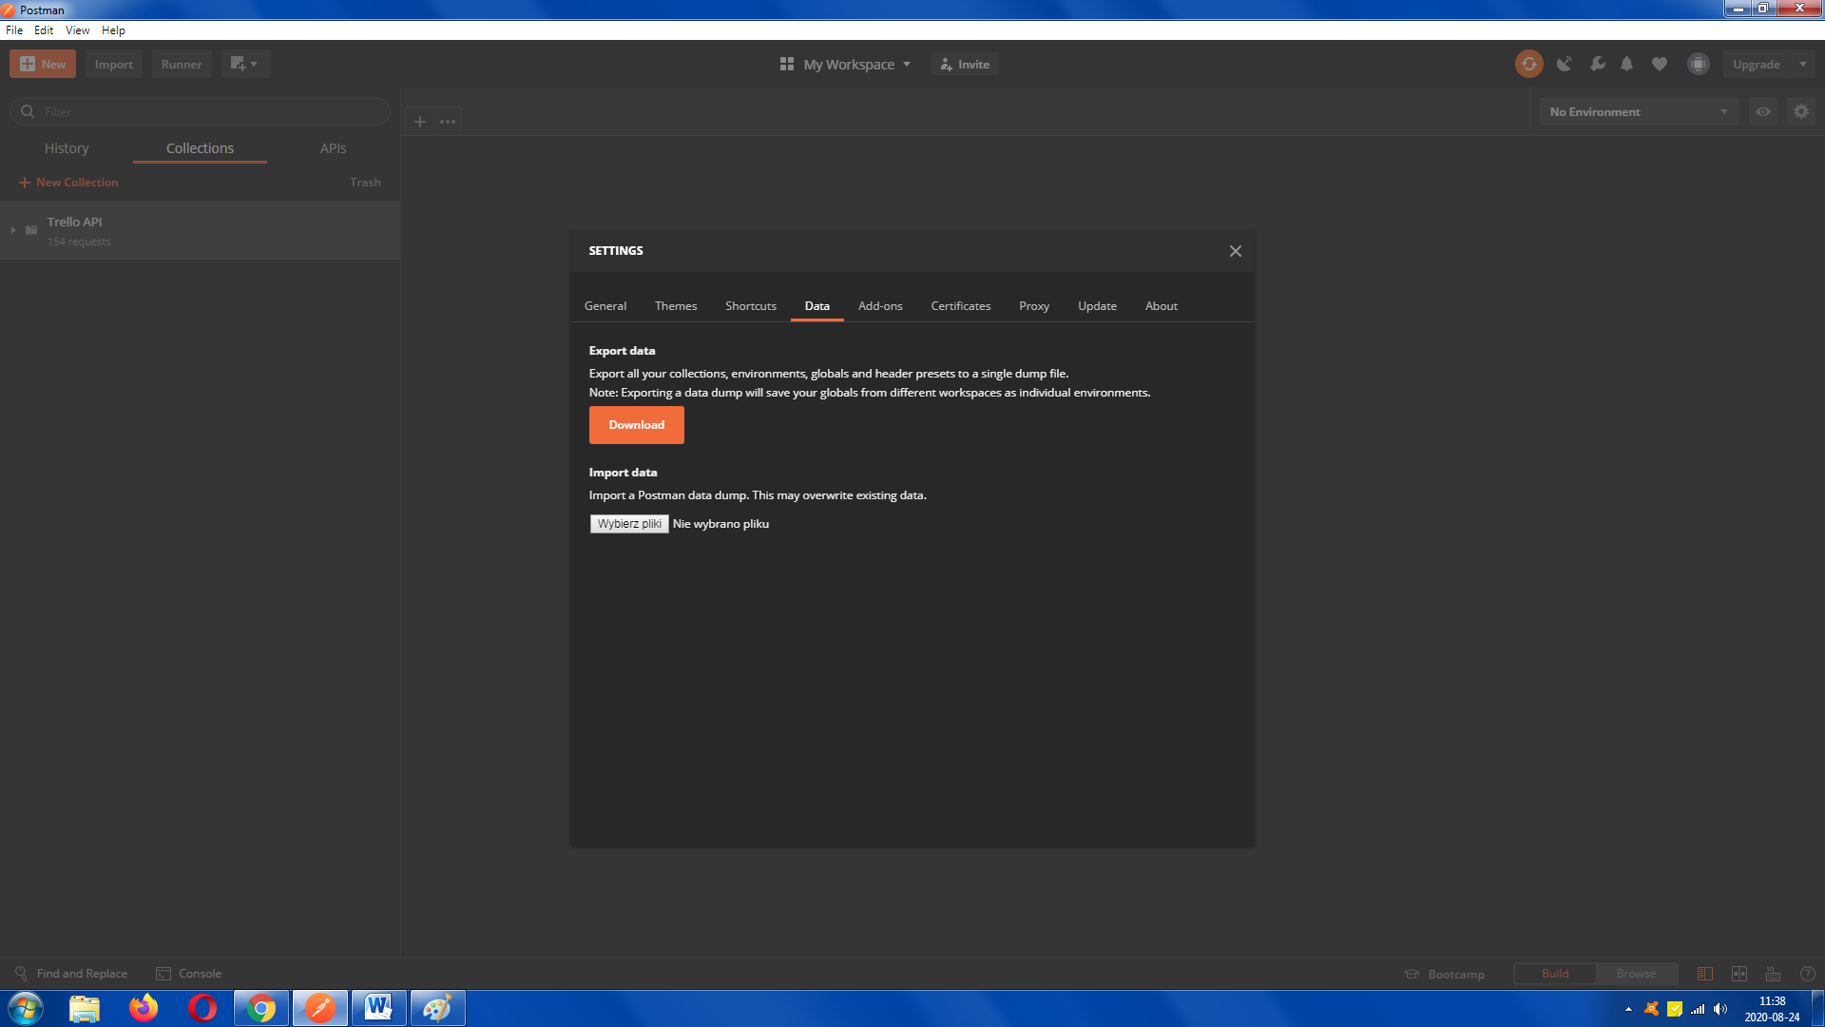

**[Postman] Trello API – screens**

Fragments of directories:

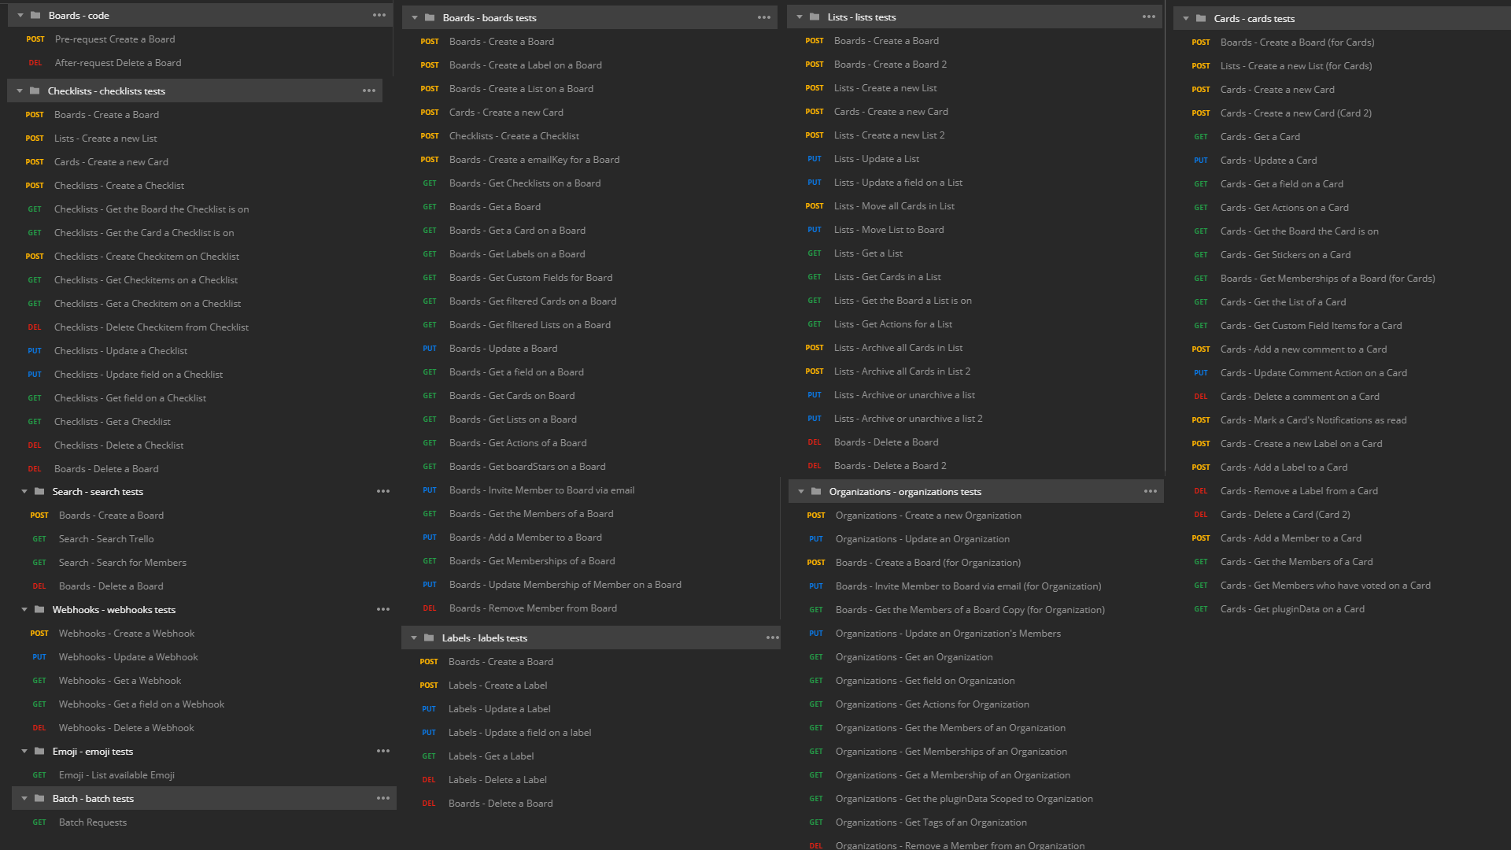

Pre-requests and After-requests examples:  
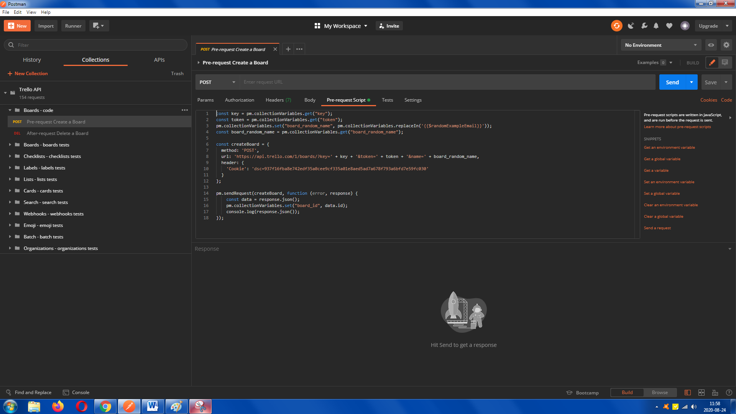

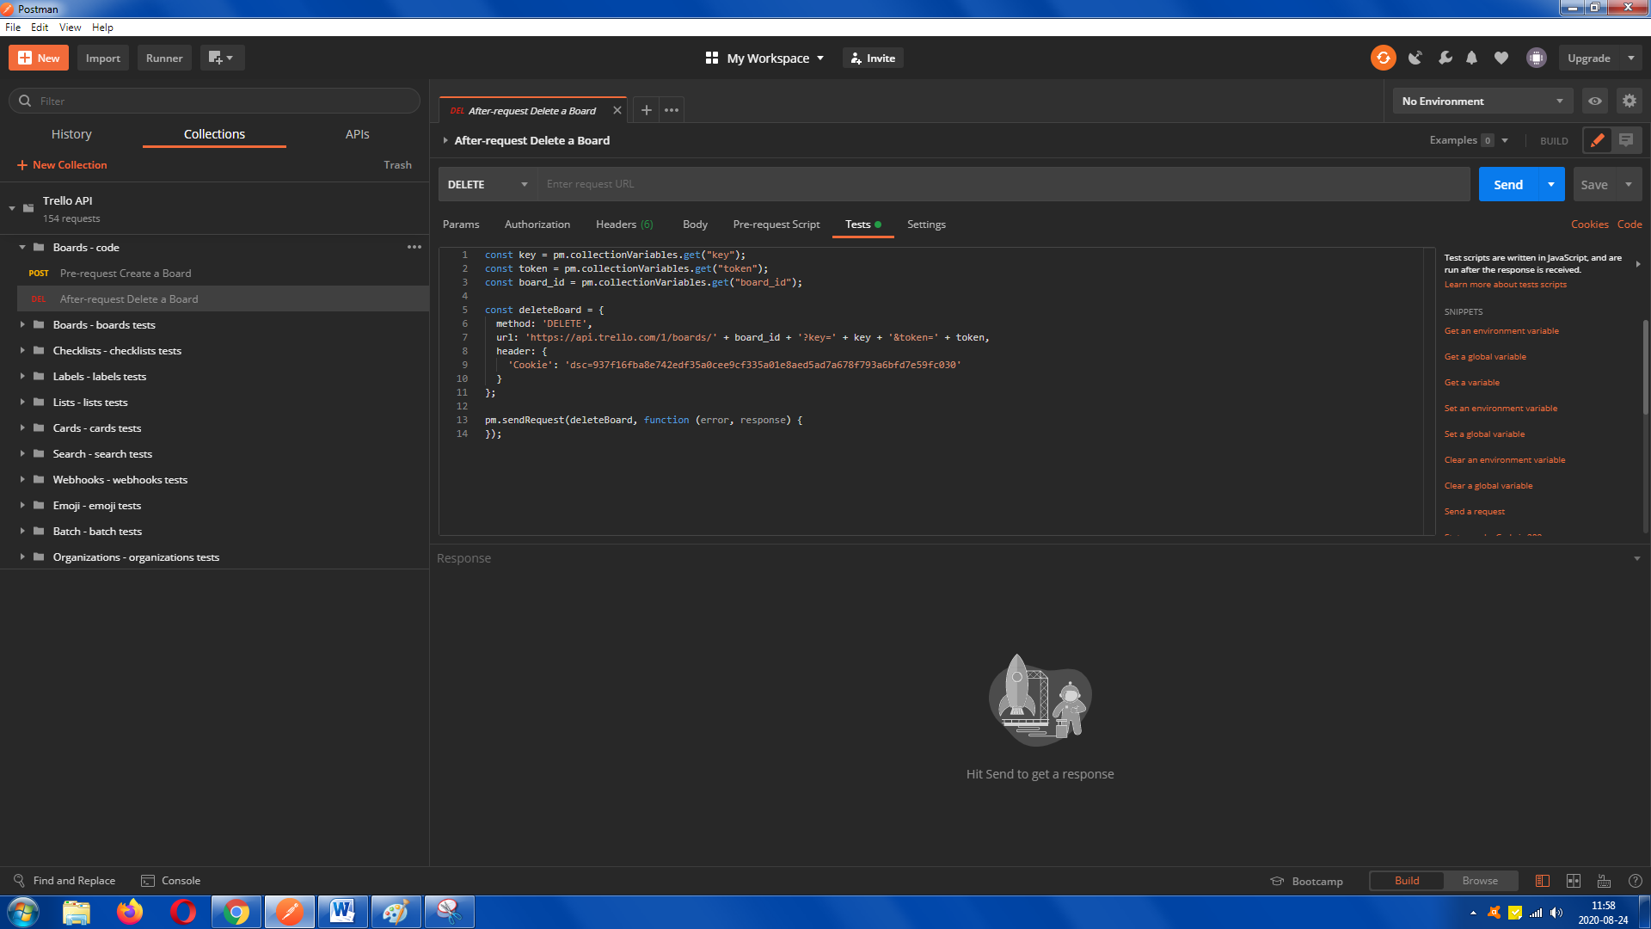

Normal requests examples:  
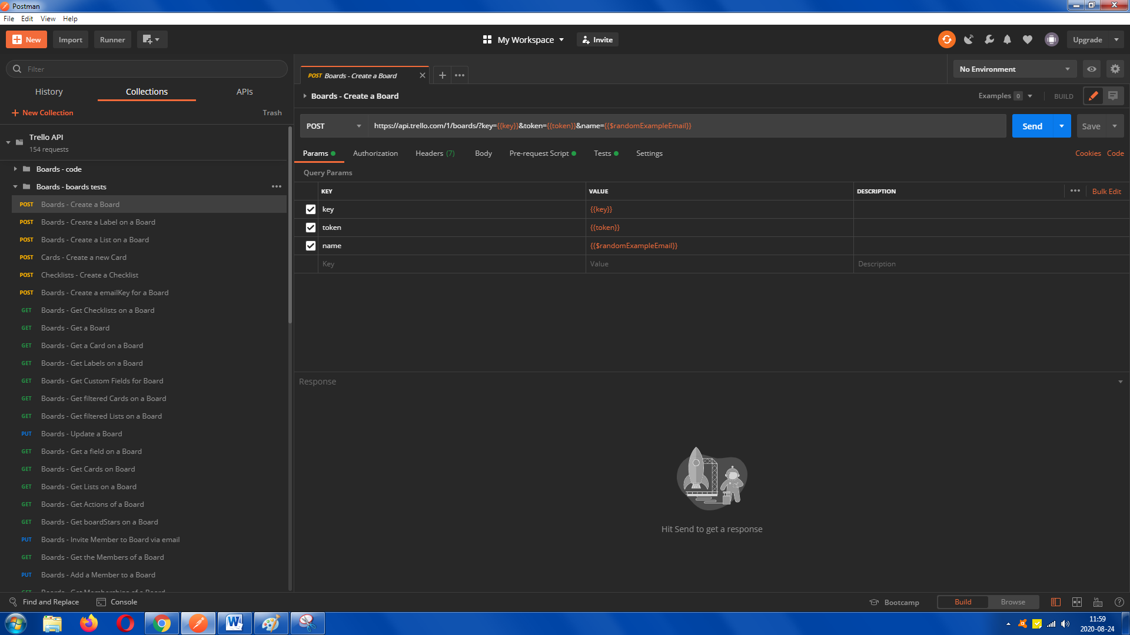

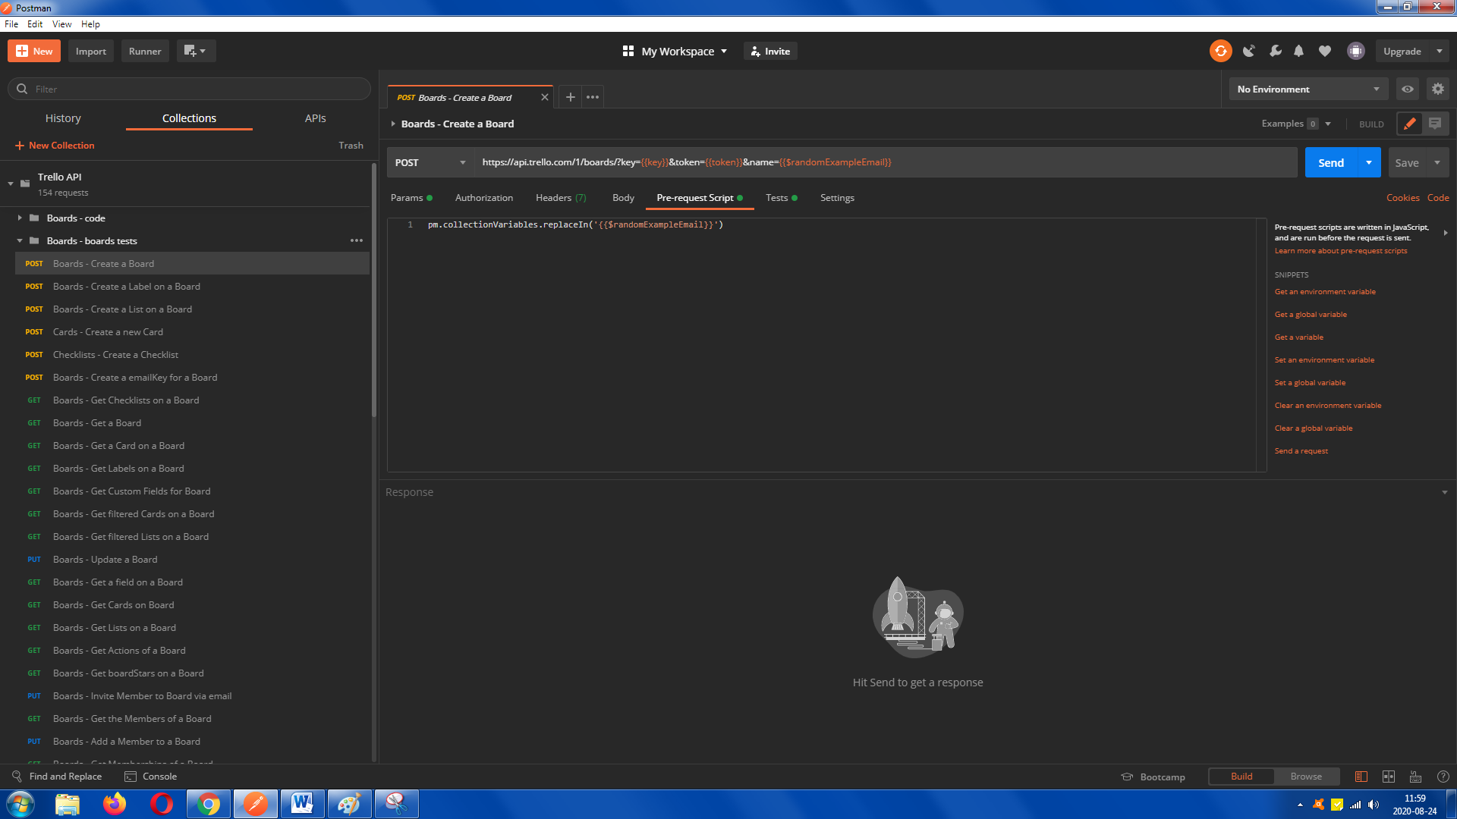

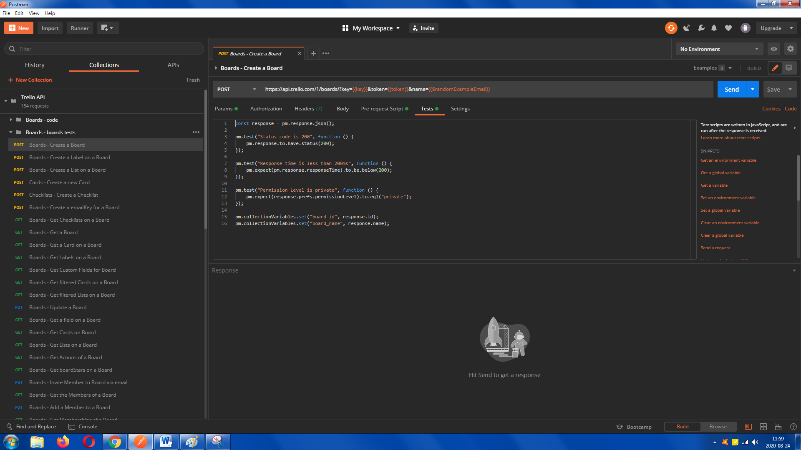

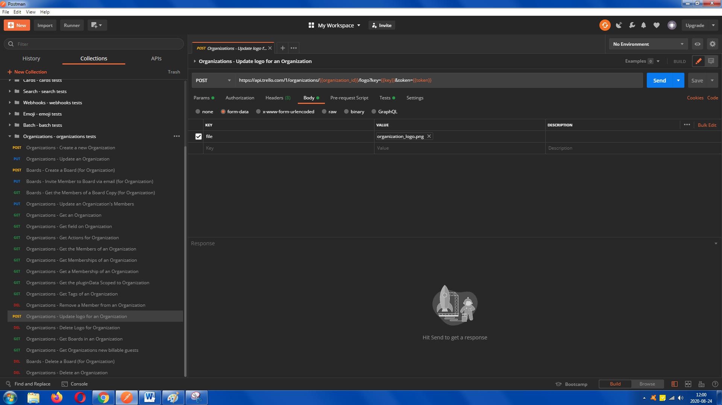

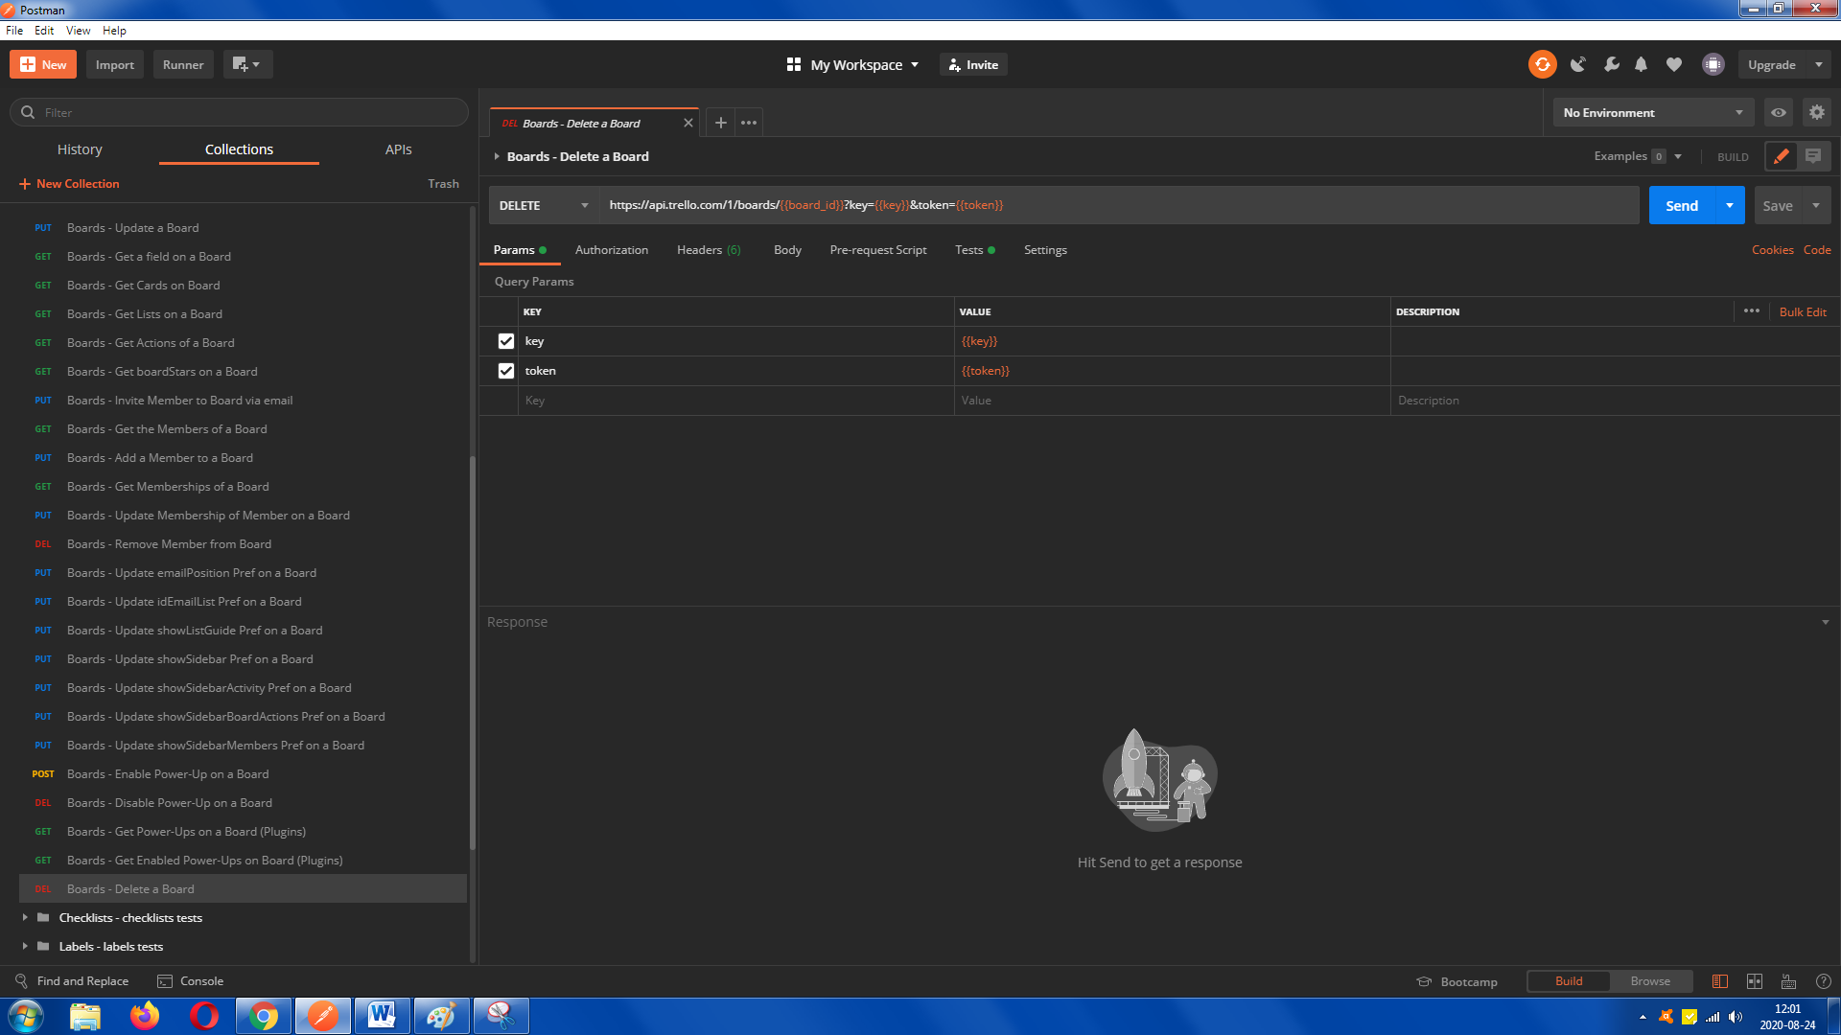

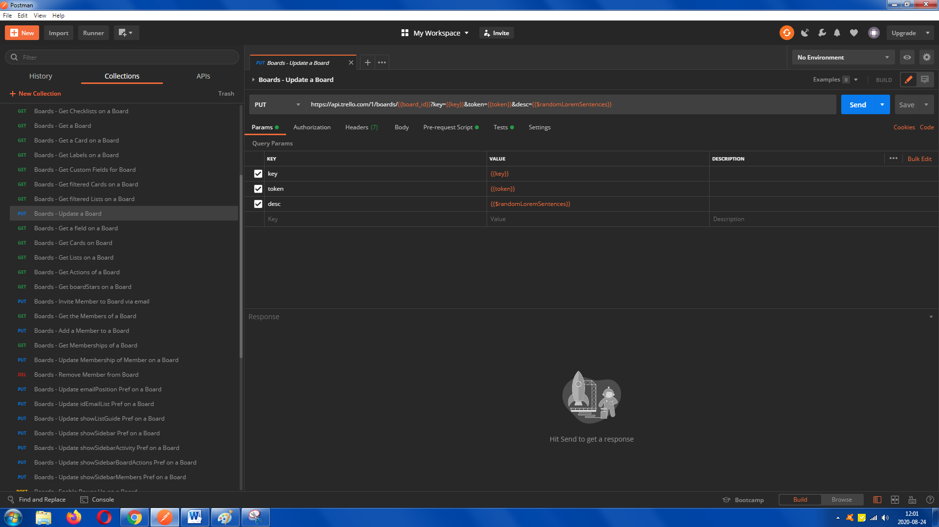

Running requests examples:  
For boards:  
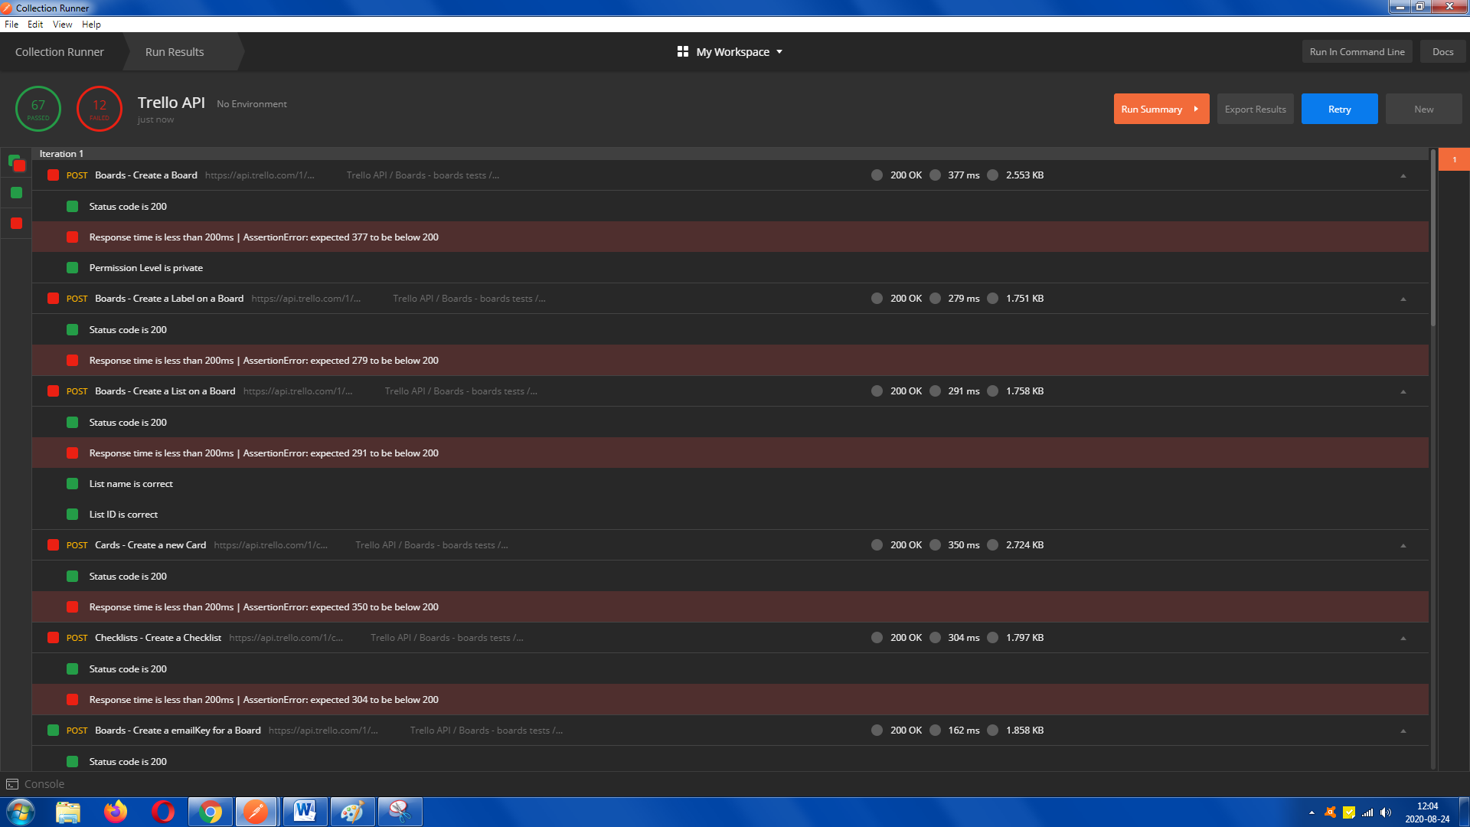

For all requests:  
(Remember before full run you should uncheck two first code request because it’s only code and doesn’t work)  
